Abdul Moiz Mansab
Muhammad Aqeel

Software Development and Construction

Projects Artifacts

Stakeholders:
Admin:

1. Manage Staff Accounts
- Add new staff
- Update staff details
- Remove staff accounts
- Monitor book issues/returns
- Track overdue and fines
- Oversee user activity
- Generate usage reports (books borrowed, categories)
- Generate fine reports
- Generate user activity reports
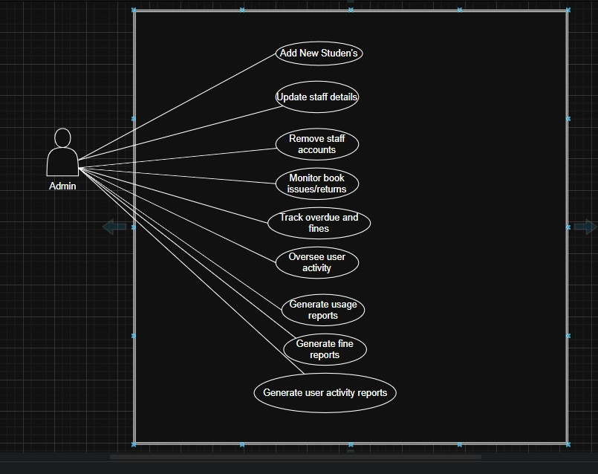

Library Staff

Issue Books
- Check book availability
- Assign due date to the user
- Record the transaction in the system
Return Books
- Receive returned books from students
- Update the system to mark book as available again ● Calculate fines (if overdue)

Maintain Records
- Keep book inventory updated (add/update/remove books)
- Track issued and returned books
- Maintain fine/overdue history
Manage Student Accounts
- Create new student accounts (with unique IDs)
- Update student information (class, name, etc.)
- Deactivate accounts for graduated/inactive students
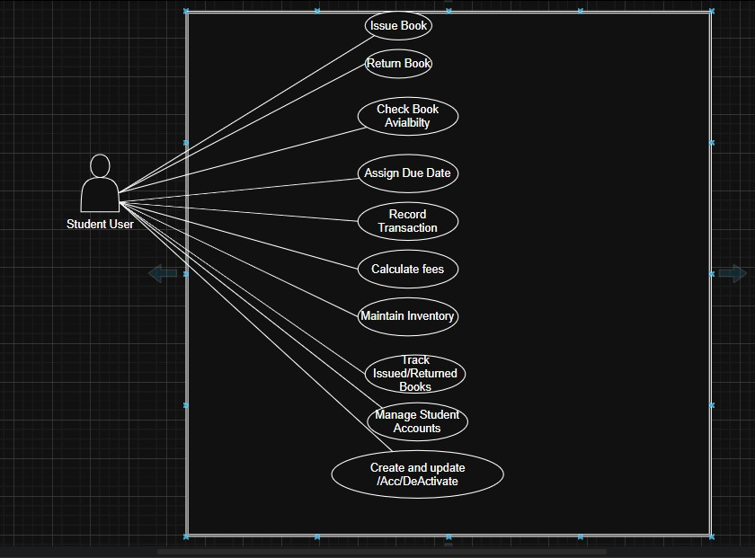
Library staff

Students/Users — Use Cases to Add in UML Diagram
- Search Catalog (by title, author, category)
- Borrow Books
- Return Books
- View Issued Books
- Check Due Dates
- View Fine Details (optional if fines are visible to students)
- Receive Notifications (due/overdue reminders)
